UNIT III
GROOMING AND PLANNING
“After we have software requirements/user stories, how does an Agile team decide what to do, how much work is involved, how to develop it, test it, and track its progress?”
1. Product Backlog (Scrum and XP)
A Product Backlog is an ordered collection of all the requirements, features, enhancements, changes, and fixes that may be needed in a product.
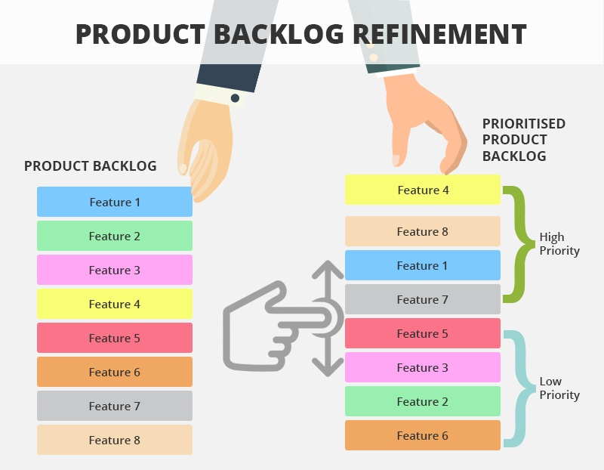
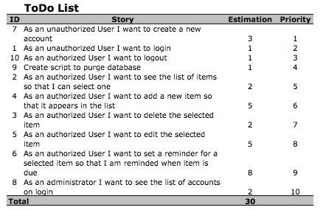
It acts as the main source of work for the Agile team.
In Agile, requirements are not considered completely fixed at the beginning.
Therefore, the Product Backlog is a living document that changes as the product, customer needs, technology, and market conditions change.
Product Backlog in Scrum
- In Scrum, the Product Backlog is closely associated with the Product Owner.
- The Product Owner is responsible for ensuring that the backlog is:
- Clearly understood.
- Ordered according to importance.
- Focused on business value.
- Updated when requirements change.
- Visible to the Scrum Team and stakeholders.

Scrum Backlog items can include:
- New features.
- User stories.
- Enhancements.
- Technical improvements.
- Bugs and defects.
- Research work.
- Maintenance work.
The items at the top of the backlog are usually:
- More important.
- Better understood.
- More detailed.
- Ready for development sooner.
Items further down the backlog may be less detailed because the team may not work on them immediately.

Product Backlog in XP
Extreme Programming also manages requirements and development work through customer-focused planning.
In XP:
- Customers identify and prioritize required features.
- Requirements are often represented as user stories.
- Developers estimate the effort required.
- Work is selected for releases and iterations.

A major XP principle is the separation of responsibilities:
- The customer decides what is important, while the dsevelopers decide how much work can realistically be completed.
- This improves collaboration and prevents unrealistic commitments.
Example: Online Shopping Application
The Product Backlog may contain:
- User registration
- User login
- Search products
- Add products to cart
- Online payment
- Order tracking
- Product reviews
- Fix payment bugs
The Product Owner orders these features based on value and priority.
For example:
Priority | Product Backlog Item
High | User Login
High | Search Products
High | Add to Cart
High | Online Payment
Medium | Order Tracking
Low | Product Reviews

2. DEEP Characteristics of a Product Backlog
A well-managed backlog can be described using DEEP.
D – Detailed Appropriately
- Backlog items should contain an appropriate amount of detail.
- High-priority items need more information because they will be developed soon.
- Low-priority items do not need extensive detail immediately.
- This prevents the team from wasting time documenting requirements that may change in the future.

E – Estimated
Items should be estimated so that the team can:
- Plan future iterations.
- Compare the relative size of work.
- Forecast delivery.
- Understand team capacity.
Estimates are usually improved as more information becomes available.

E – Emergent
The backlog continuously evolves.
New requirements can be:
- Added.
- Changed.
- Removed.
- Reprioritized.
The product backlog is therefore not fixed permanently.

P – Prioritized
Items must be ordered according to importance.
Factors affecting priority include:
- Business value.
- Customer value.
- Risk.
- Urgency.
- Market demand.
- Technical dependencies.

3. Prioritization of Stories
- Prioritization determines which requirements should be developed first.
- Agile teams cannot usually develop everything at once. Therefore, they must select the work that provides the greatest value.
- The Product Owner normally works with customers and stakeholders to prioritize stories.

Factors Used for Prioritization
Stories may be prioritized according to:
Business Value
Features that provide significant benefits to the business may receive higher priority.
Examples include features that:
- Increase revenue.
- Reduce costs.
- Attract customers.
- Improve competitiveness.

Customer Value
A feature may be prioritized if it solves an important customer problem or improves customer satisfaction.

Urgency
Some requirements must be completed quickly because of:
- Market opportunities.
- Legal requirements.
- Customer commitments.
- Business deadlines.

Risk
High-risk requirements may be developed earlier so that technical or business problems can be discovered quickly.

Dependencies
Some stories must be completed before other stories can begin.
Therefore, dependencies can affect the order of implementation.

MoSCoW Prioritization
MoSCoW is a common prioritization technique.
Must Have
Requirements that are essential.
Without them, the product or release cannot achieve its main purpose.
For an online learning application:
Must Have
- Student login.
- View courses.
- Watch lessons.
Without these features, the application cannot achieve its main purpose.
Should Have
- Download course materials.
- Receive notifications.
Important but the first release can possibly function without them.
Could Have
- Dark mode.
- Personalized themes.
Useful but not essential.
Won't Have
- Virtual reality classroom for the current release.
It may be considered in a future release.

Should Have
Important requirements that provide significant value but are not absolutely essential.
They may be postponed if necessary.

Could Have
Useful and desirable requirements.
They are included if sufficient time and resources are available.

Won't Have
Requirements that are deliberately excluded from the current release.
They may be reconsidered in the future.

Kano Model
The Kano Model studies the relationship between product features and customer satisfaction.
Basic Features
Customers expect these features as normal.
If they are missing, customers become dissatisfied.

Performance Features
Customer satisfaction increases when the performance of these features improves.

Delighter Features
These features are unexpected and can greatly increase customer satisfaction.
Over time, however, customers may begin to expect them.
Therefore, a feature that is initially a delighter may eventually become a basic expectation.

4. Estimating
Estimation is the process of determining the approximate effort required to complete work.
Agile estimation recognizes that estimates are not exact predictions. They are used to support planning and decision-making.
Estimation may consider:
- Effort.
- Complexity.
- Size.
- Risk.
- Uncertainty.

A. T-Shirt Sizing
Work is classified into relative sizes such as:
- Small.
- Medium.
- Large.
- Extra Large.
This technique is useful during early planning when detailed information is not yet available.
Its advantage is that it is:
- Simple.
- Quick.
- Easy to understand.

B. Ideal Time
Ideal time is the amount of time needed to complete work under perfect conditions.
It assumes there are:
- No interruptions.
- No meetings.
- No unexpected problems.
- No distractions.
Actual calendar time may be longer than ideal time.

C. Estimation in Hours
Detailed tasks can be estimated in hours.
This is particularly useful when:
- The work has been broken into smaller tasks.
- More detailed information is available.
- The team is planning an iteration.

D. Story Points
Story points provide a relative estimate of the size of a user story.
They may represent:
- Complexity.
- Effort.
- Risk.
- Uncertainty.
Story points are not necessarily equivalent to hours.
For example, a story estimated as 8 points is considered relatively larger or more complex than a story estimated as 3 points.
A Fibonacci-like sequence is commonly used:
1, 2, 3, 5, 8, 13, 21
Larger numbers reflect increasing uncertainty.

E. Planning Poker
Planning Poker is a collaborative estimation technique.
Process
- A user story is presented to the team.
- The team discusses the requirement.
- Each member independently selects an estimate.
- Estimates are revealed simultaneously.
- Differences are discussed.
- The team estimates again.
This process continues until the team reaches a reasonable agreement.
Advantages
Planning Poker:
- Involves the whole team.
- Encourages discussion.
- Reduces the influence of dominant individuals.
- Improves understanding.
- Uses the knowledge of multiple team members.

5. Scrum: Product Backlog Grooming
Product Backlog Grooming is the continuous process of reviewing and improving backlog items.
It prepares requirements for future development.
During grooming, the team may:
- Review existing stories.
- Clarify unclear requirements.
- Add details.
- Add acceptance criteria.
- Split large stories.
- Estimate stories.
- Re-estimate stories.
- Reprioritize work.
- Add new requirements.
- Remove unnecessary requirements.
The purpose is to ensure that important stories are ready when Sprint Planning begins.

Breaking Down Large Stories
Large stories may be too complex to complete in one Sprint.
They must therefore be divided into smaller stories.
Smaller stories are easier to:
- Understand.
- Estimate.
- Develop.
- Test.
- Deliver.

Velocity
Velocity represents the amount of work a team has completed in previous iterations.
It can help the team predict how much work it may be able to complete in the future.
Velocity should be used as a planning aid rather than as a measure for comparing teams.

Definition of Done
The Definition of Done explains when work can truly be considered complete.
Depending on the project, this may include:
- Coding completed.
- Code reviewed.
- Testing completed.
- Defects resolved.
- Code integrated.
- Acceptance criteria satisfied.
The Definition of Done improves consistency and prevents incomplete work from being considered finished.

Technical Debt
Technical debt refers to technical work that has been postponed.
For example:
- Poorly structured code.
- Missing tests.
- Temporary solutions.
- Outdated components.
Ignoring technical debt can create problems in future development.
It may:
- Increase maintenance effort.
- Reduce development speed.
- Increase defects.
- Make changes more difficult.

6. Scrum: Sprint Planning
Sprint Planning is conducted before the Sprint begins.
Its purpose is to decide:
- What work will be performed?
- How will the work be completed?

Step 1: Select Product Backlog Items
The team selects high-priority items from the Product Backlog.
The selection depends on:
- Priority.
- Team capacity.
- Velocity.
- Complexity.
- Available time.
- Maintenance work.
- Bugs.
- Technical debt.

Step 2: Define the Sprint Goal
The Sprint Goal gives the team a common purpose.
It describes what the Sprint is intended to achieve.

Step 3: Break Stories into Tasks
User stories are divided into smaller technical tasks.
Examples may include:
- Designing.
- Coding.
- Testing.
- Integration.

Step 4: Estimate the Work
Tasks are estimated so that the team can determine whether the planned work is realistic.

Output of Sprint Planning
Sprint Goal
The overall objective of the Sprint.
Sprint Backlog
The selected stories and the work required to complete them.
The Sprint Backlog acts as the team's plan for the Sprint.

7. Extreme Programming: XP Planning Game
The XP Planning Game is a collaborative approach used to plan software development.
It involves both:
- Customers.
- Developers.
The Planning Game connects:
- Business priorities.
- Technical estimates.

Release Planning
Release Planning focuses on:
- Selecting requirements.
- Estimating effort.
- Prioritizing features.
- Determining release content.
Customers decide which functionality is most valuable.
Developers provide technical estimates.

Iteration Planning
Iteration Planning focuses on the work to be completed during the next iteration.
Developers:
- Break stories into tasks.
- Estimate the tasks.
- Decide what they can realistically complete.

Three Phases
Exploration
Possible requirements and ideas are explored.
Commitment
The team decides what work it can realistically perform.
Steering
Plans are adjusted as new information becomes available.
This supports the Agile principle that plans should be adaptable.

8. Maintenance of Legacy Code
Legacy code refers to existing software that continues to require:
- Maintenance.
- Bug fixes.
- Enhancements.
- Technical improvements.
Agile teams may have to balance new feature development with unexpected maintenance work.
This can create difficulties because maintenance requests may arrive without warning.

Approach 1: Reserve Capacity
The team deliberately commits to less work than its full capacity.
The remaining capacity is used for:
- Urgent bugs.
- Production problems.
- Maintenance.

Approach 2: Assign a Team Member
One team member may focus primarily on:
- Support.
- Maintenance.
- Unexpected issues.
This allows other team members to focus on planned Sprint work.

Approach 3: Separate Teams
A large organization may use:
- One team for new development.
- Another team for maintenance and support.
This can improve focus but may require additional coordination.

9. Triple Constraints
The traditional project-management constraints are:
- Scope
- Time
- Resources
These constraints are connected.
Example
If the scope increases:
- More time may be required, or
- More resources may be required.
If the deadline is reduced:
- Scope may need to decrease, or
- Resources may need to increase.
Agile accepts that changes occur and uses iterative planning to manage these constraints.

PART B: TESTING, QUALITY AND INTEGRATION
1.Quality in Agile
Quality is not something that is checked only after development is complete.
Agile emphasizes building quality throughout the development process.
Quality activities include:
- Continuous testing.
- Frequent integration.
- Code review.
- Refactoring.
- Automated testing.
The goal is to discover problems as early as possible.
Early detection reduces the cost and difficulty of fixing defects.

Creating a Quality-Focused Culture
Quality is the responsibility of the entire Agile team.
A quality-focused culture encourages:
- Personal responsibility.
- Collaboration.
- Early defect detection.
- Continuous improvement.
- Technical excellence.
Quality cannot depend only on a separate testing department.
Developers, testers, Product Owners, and other stakeholders all contribute to product quality.

Pair Programming
Pair Programming is an XP practice where two programmers work together.
Driver
The driver:
- Writes code.
- Controls the keyboard.
- Focuses on the immediate implementation.
Observer
The observer:
- Reviews the work.
- Identifies possible errors.
- Thinks about design.
- Suggests improvements.
The two programmers regularly switch roles.
Benefits
Pair programming can provide:
- Immediate code review.
- Knowledge sharing.
- Improved communication.
- Better code quality.
- Reduced dependence on a single developer.
- Cross-training.

Test-Driven Development (TDD)
TDD is a development practice in which testing occurs before the required code is written.

Process
1. Write a test
A test is created for the desired functionality.
2. Run the test
Initially, the test fails because the functionality does not yet exist.
3. Write the code
Only enough code is written to make the test pass.
4. Run the test again
The developer verifies that the code works.
5. Refactor if necessary
The internal code structure can be improved while ensuring the test still passes.
Benefits
TDD:
- Encourages early testing.
- Improves confidence.
- Supports regression testing.
- Reduces unnecessary code.
- Supports refactoring.

2. Refactored Code
Refactoring means improving the internal structure of existing code without changing its external behaviour.
The user should receive the same functionality, but the code behind the functionality becomes better organized.
Reasons for Refactoring
- Improve readability.
- Reduce complexity.
- Remove duplication.
- Improve maintainability.
- Make future modifications easier.
- Improve software design.

Relationship with Testing
Automated tests are important because they help confirm that refactoring has not introduced defects.

PART C: TRACKING AND REPORTING
1. Kanban
Kanban manages work using a visual workflow.
Instead of planning all work into fixed Sprints, Kanban supports continuous movement of work.
A typical workflow may be:
To Do → In Progress → Testing → Done
Work is represented using cards that move across the workflow.

Main Characteristics of Kanban
1. Visualize Workflow
The Kanban board makes the work visible.
The team can quickly identify:
- Current work.
- Completed work.
- Bottlenecks.
- Delays.

2. Limit Work in Progress (WIP)
A WIP limit restricts the amount of work allowed in a particular stage.
For example, only a certain number of tasks may be allowed in the In Progress column.
Benefits include:
- Reduced multitasking.
- Better focus.
- Easier identification of bottlenecks.
- Improved flow.

3. Measure Lead Time
Lead time measures how long it takes for work to move from request to completion.
Reducing lead time helps organizations respond faster to customer needs.

2. Lean Waste in Kanban
Kanban and Lean focus on reducing waste.
• Muda (Waste): Activities that consume time or resources but add zero value for the customer.
• Mura (Roughness): Fluctuations, irregularities, or inconsistency in a workflow or demand.
• Muri (Overburden): Pushing people, teams, or machines past their natural limits or safe capacity.
By visualizing work and limiting WIP, teams can identify and reduce these forms of waste.

3.Tracking
Tracking helps Agile teams understand:
- Current progress.
- Remaining work.
- Problems.
- Risks.
- Delivery performance.
Tracking should support transparency and decision-making.

Burn-Down Chart
A Burn-Down Chart shows:
- Remaining work.
- Progress over time.
It is commonly used to monitor Sprint progress.
The ideal trend is for remaining work to gradually decrease toward zero.

Burn-Up Chart
A Burn-Up Chart shows:
- Work completed.
- Progress toward the total target.
It is useful for understanding progress toward a release.

Information Radiators
Information radiators display important information where the team can easily see it.
Examples include:
- Progress charts.
- Build status.
- Defect information.
- Project status.
- Team metrics.
They improve transparency and communication.

FDD Parking Lots
Feature-Driven Development may use parking lots to provide a high-level view of project progress.
They can show:
- Features.
- Completion status.
- Story points.
- Percentage completed.
- Project health.
They are particularly useful for large projects.

4.Meetings or Ceremonies
Agile uses regular meetings to support communication and continuous improvement.

Daily Stand-Up
The Daily Stand-Up is a short daily meeting.
Common questions are:
- What did I complete yesterday?
- What will I do today?
- What problems or impediments are blocking me?
Purpose
The meeting helps:
- Coordinate the team.
- Identify problems early.
- Improve transparency.
- Keep everyone informed.
It is normally short and focused.

5.Sprint Review
The Sprint Review occurs after a Sprint.
The team demonstrates the completed product increment.
Stakeholders can:
- Review the completed work.
- Provide feedback.
- Discuss changes.
- Influence future priorities.
The focus is on working software and the actual product.

6.Retrospective
The Retrospective focuses on improving the way the team works.
The team discusses:
- What went well.
- What went poorly.
- What problems occurred.
- What improvements should be made.
The main objective is continuous improvement.

7.Measuring Success in Agile
Agile success should not be measured only by whether all planned features were completed.
Success should consider both the product and the team's ability to continue delivering value.
The main categories are:
A. Do It Fast
Measures:
- Productivity.
- Speed.
- Responsiveness.
- Delivery capability.

B. Do It Right
Measures:
- Product quality.
- Defect levels.
- Customer satisfaction.

C. Do It on Time
Measures:
- Predictability.
- Reliable delivery.
- Consistent delivery.

D. Keep Doing It
Measures whether the team can continue working effectively.
Important considerations include:
- Employee satisfaction.
- Sustainable pace.
- Team stability.

Customer Satisfaction
Customer satisfaction is one of the most important indicators of Agile success.
A successful Agile product should:
- Meet customer needs.
- Deliver useful functionality.
- Maintain quality.
- Respond to change.
- Provide value.

